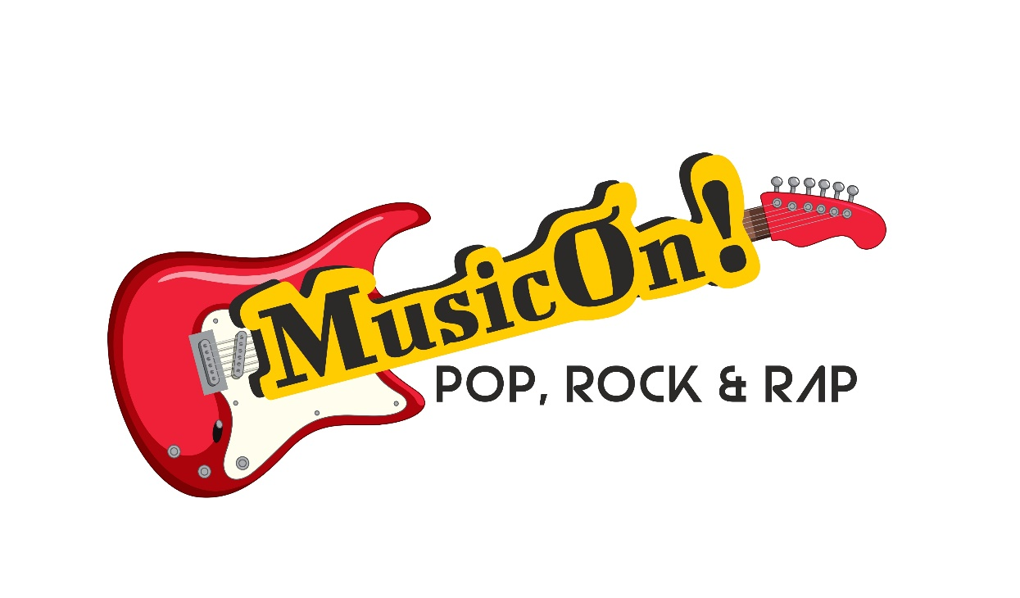
What is Musicon?
A new music event from the old hands of music events- Slipdisc.
Musicon is a day long, competition format event—EXCEPT—it is way more chill than Battle of the Bands. It promises the same magic of pure, live music in different genres.
If BTB conjures up images of adrenaline-stoked, leather jacketed and tattooed, metal heads, then Musicon is a gathering of chill musicians- who are more like surfers dudes and surfer babes.
Musicon promises a relaxed competition. Make no mistake, surfers are also adrenalin junkies, always catching the biggest wave- but there’s a difference in their attitude, and it this chill attitude that will make Musicon a unique event.
Not Cut-throat competition, but a relaxed, chill competition amongst musicians who are secure about their scintillating auras.
Full-fledged Bands can participate, as well as solo performers/ 2-man bands etc. Rappers with a single music instrument also welcome. Beatboxing accompaniment also welcome.

The event is slated for next year- on 26-1-26, at Emerald’s Chill Out Lounge & Restobar (Guirim). You have enough time to prepare, you have been given an advance heads up!

RULES
- Genres: Pop, Rock & Rap (with emphasis on Rap)
- English, Konkani, Portuguese, Marathi (and any other regional language welcome)
- 3 songs per competing band/ individual (all covers, or a combo of originals and covers) You can do all 3 in Pop genre, or all 3 Rock, or all 3 Rap. Or a mix and match of all 3 or 2 genres of your liking and expertise
- Cash prizes + Gift Hampers
- Judges decision will be final. No influencing judges
- Neutral Judges who are stalwarts from the music industry
- Several more awards to win. Every Band goes home with some award or hamper
- Typed lyrics of original songs to be submitted to judges on Event-Day (TYPED- not HANDWRITTEN)
- Band Registration fee: Rs 2500/-
- Event Tickets to be sold at Rs 500/-
- Every participating band will get limited FREE Passes for friends/ Family
- Every Participating band will get one round of FREE DRINKS

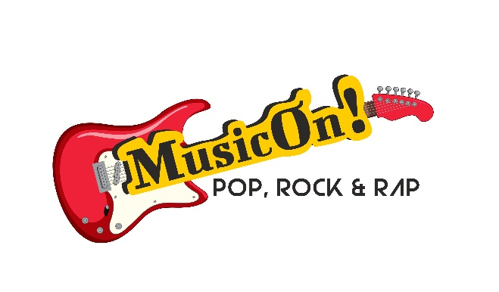
Registration Form for Musicon

NAME/S:

AGE:
ADDRESS:

MOBILE & EMAIL:

Received with thanks the sum of Rs 2500/- from Band leader/solo performer
Mr/ Ms

For SLIPDISC Advertising & Events

